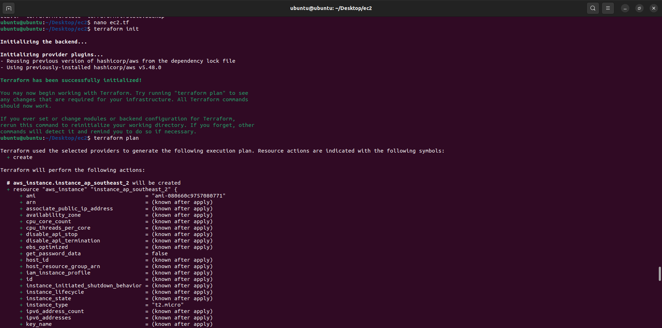

1(creating tf file)

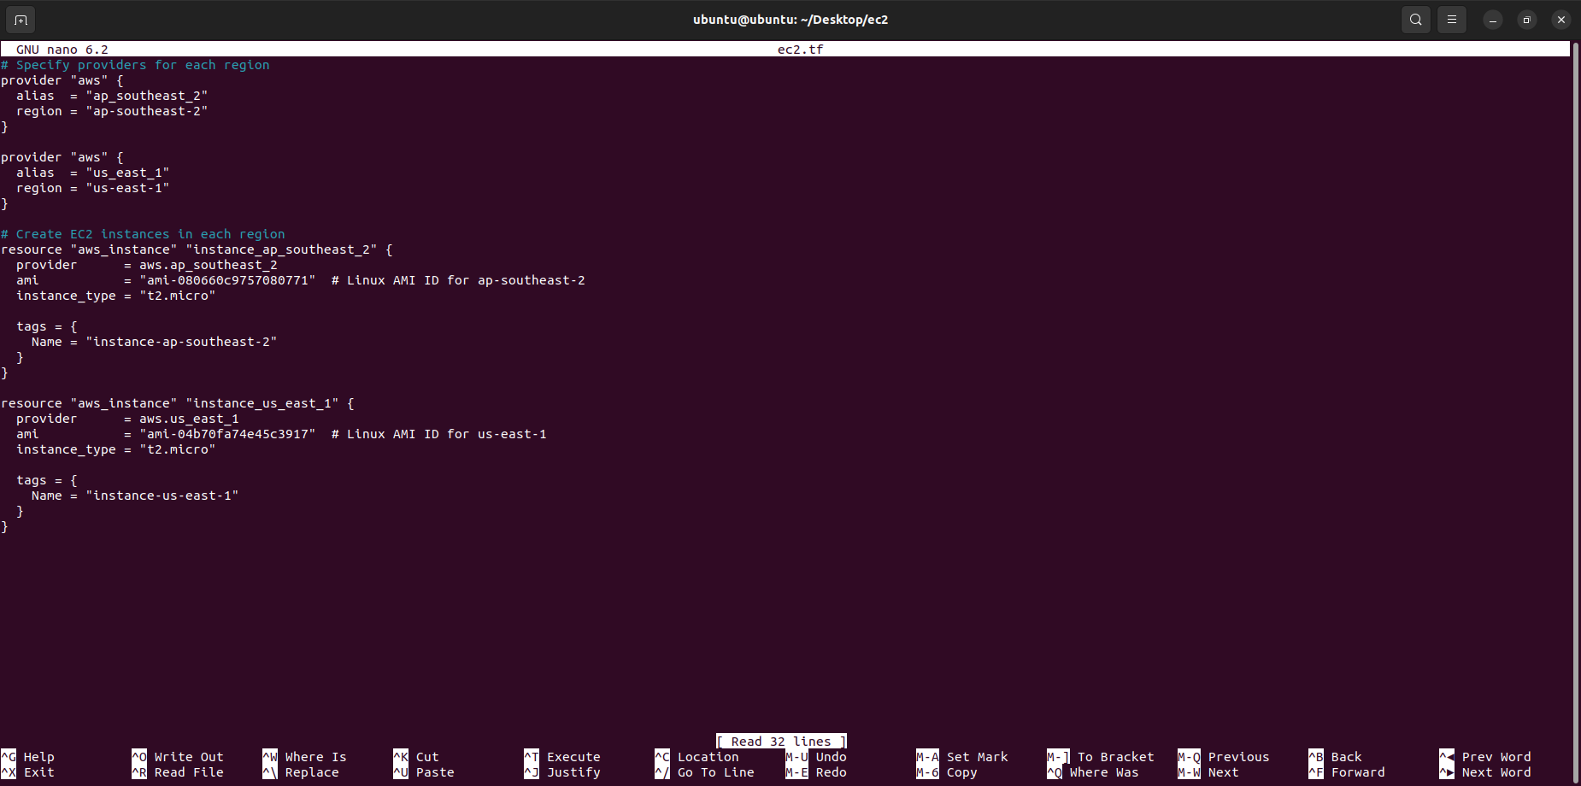

2(terraform file)



3(terraform apply)

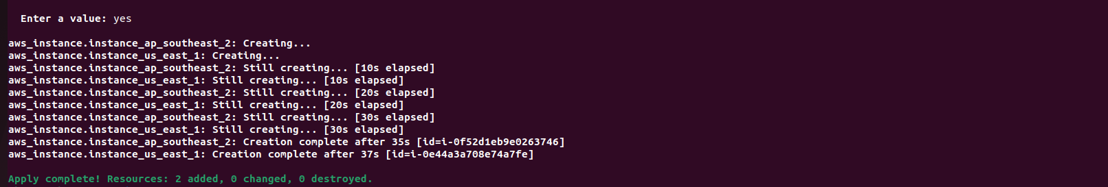

4(output)

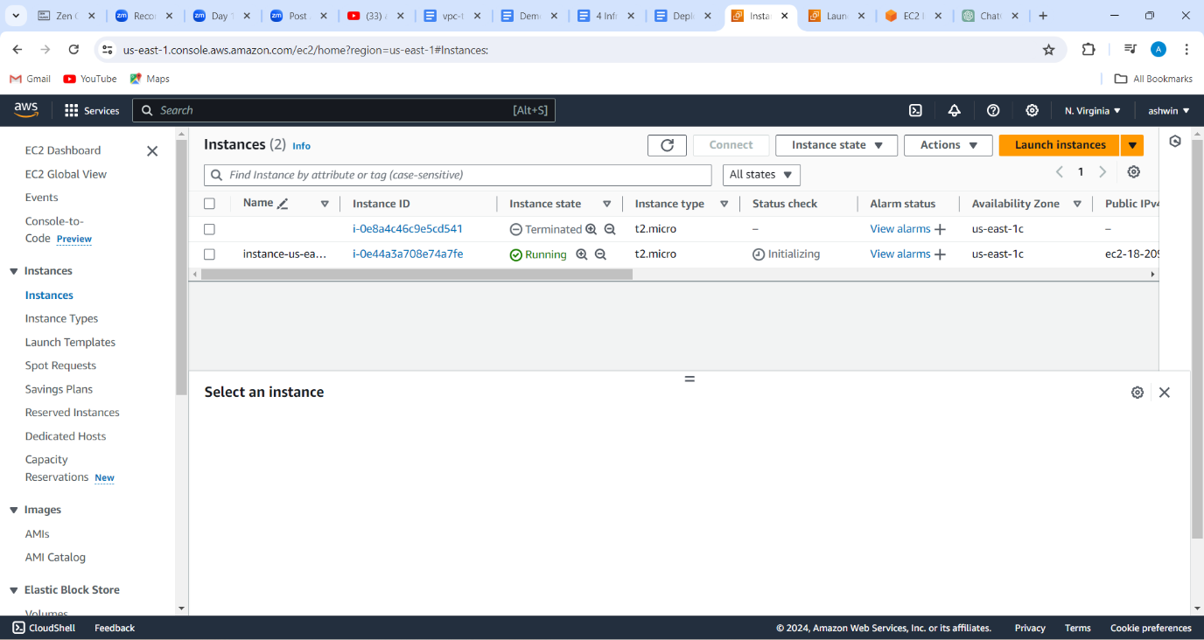

5(created ec2 instance in n.virginia reg)

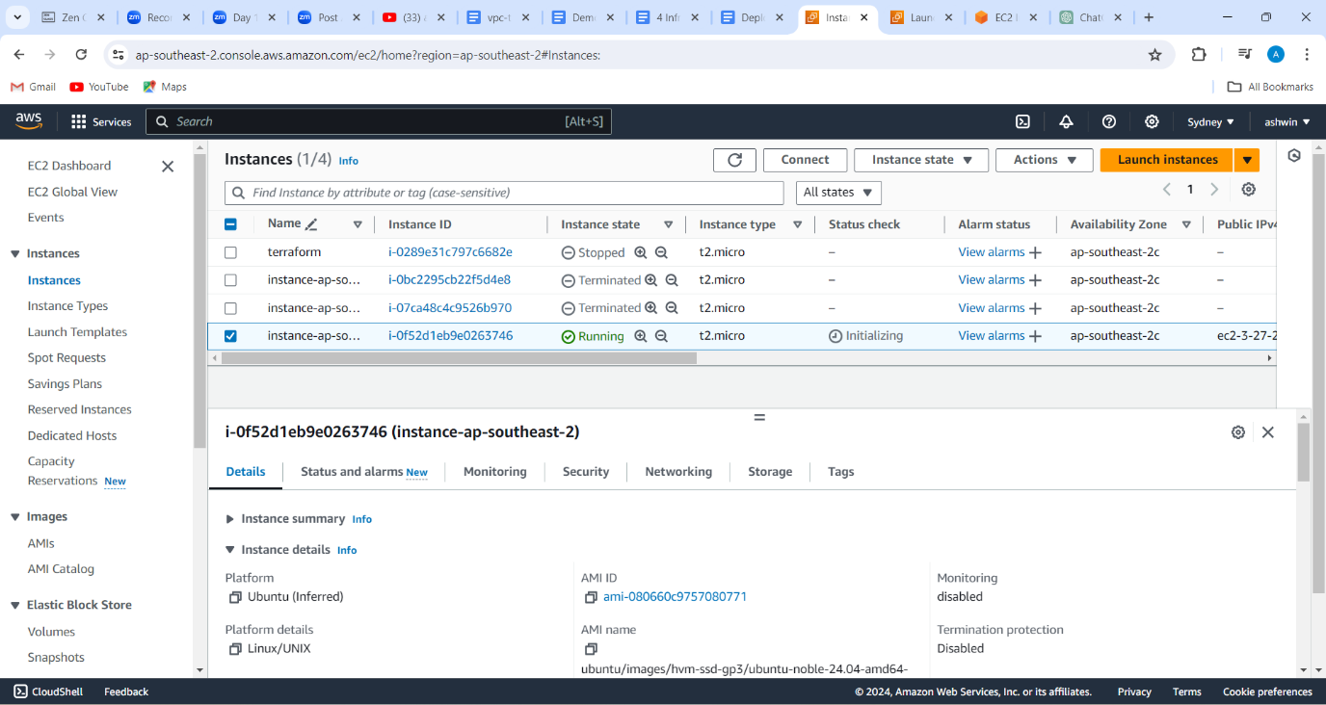

6(created ec2 instance in sydney reg)